Vyntra – Online Clothing Store

Goal Of Our Application:

We build an e-commerce application that performs user authentication/user registration before giving user access to our hosted products on the platform.

Actors Of The System-

* Admin
* Users

User can –

1. Login with existing username and password.
2. User can register for fresh username if he/she does not have an already existing account.
3. After user authentication, user can –

* View Products
* Search for Products
* Add them to cart
* Update Cart by choosing various quantities of products as per choice and need.
* Cart Amount automatically updated once quantities of products in cart are changed.
* User can choose from 2 methods of payment-
  + Cash On Delivery
  + Card Payment – We have mocked this service using stripe payment gateway.

Admin can –

1. Admin Username: admin

Admin Password: 123456789

1. Manage Existing Products by ‘**Edit’** option. It allows admin to change all attributes related to the product that is visible to the user.
2. Add a new product to the database using **‘Add New Product’** option.

Technology Used:

1. Angular 9
2. Spring Boot
3. Jwt Authentication for authorization of users and admins
4. Hibernate for accessing database in our local system.

The diagram below show how our system handles User Registration and User Login processes:

Spring API

Angular

1. DELETE api/products/{id}

3. Reload to manage products page.

3. Return message “Product Saved Successfully”

2. Check JWT Signature and return page to edit/update products

2. Check JWT Signature and give permission to delete a product from database.

5. Check JWT Signature. Get List Of Products using user’s authorities.

1. PUT api/products/{id}

ADMIN

ACTIVITIES

6. Return Response Data

USER

LOG IN

4. GET api/products [on authorization header]

1. POST api/auth/signin with AuthLoginInfo(username, password)

3. Return JwtResponse(token, type, username, authorities)

2. Authenticate with username, password. Create JWT string with a secret.

3. Return response message “Registered Successfully”

1. POST api/auth/signup with SignUpInfo (name, username, email, role, password)

2. Check Existing Save in **UserPrinciple**() to database.

USER

REGISTRATION

**Images of the prototype:**

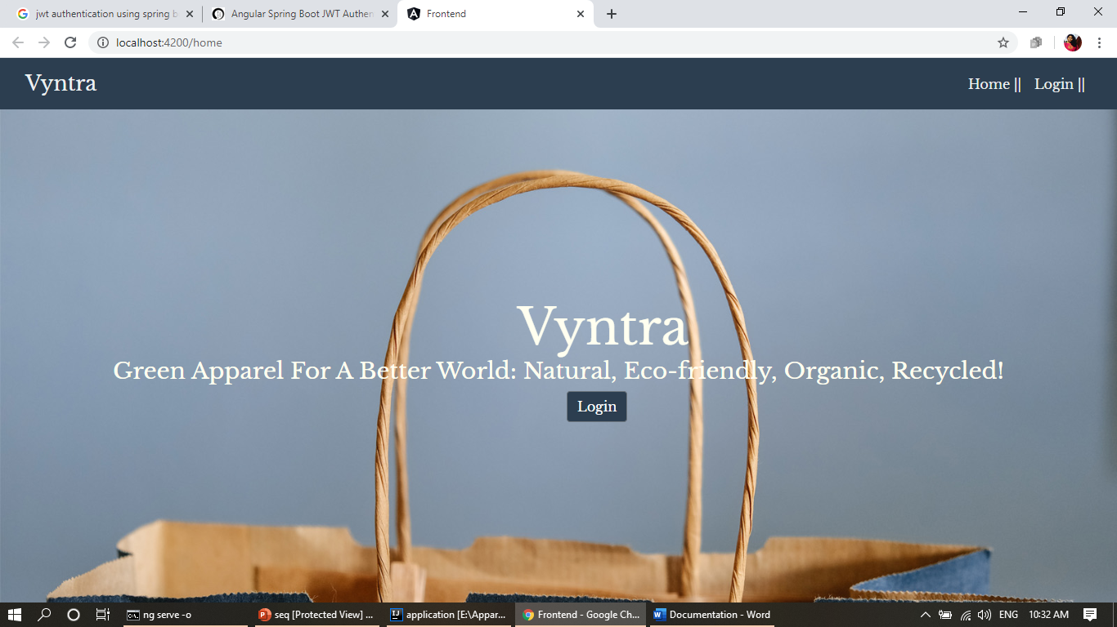

Image 1: Landing Page

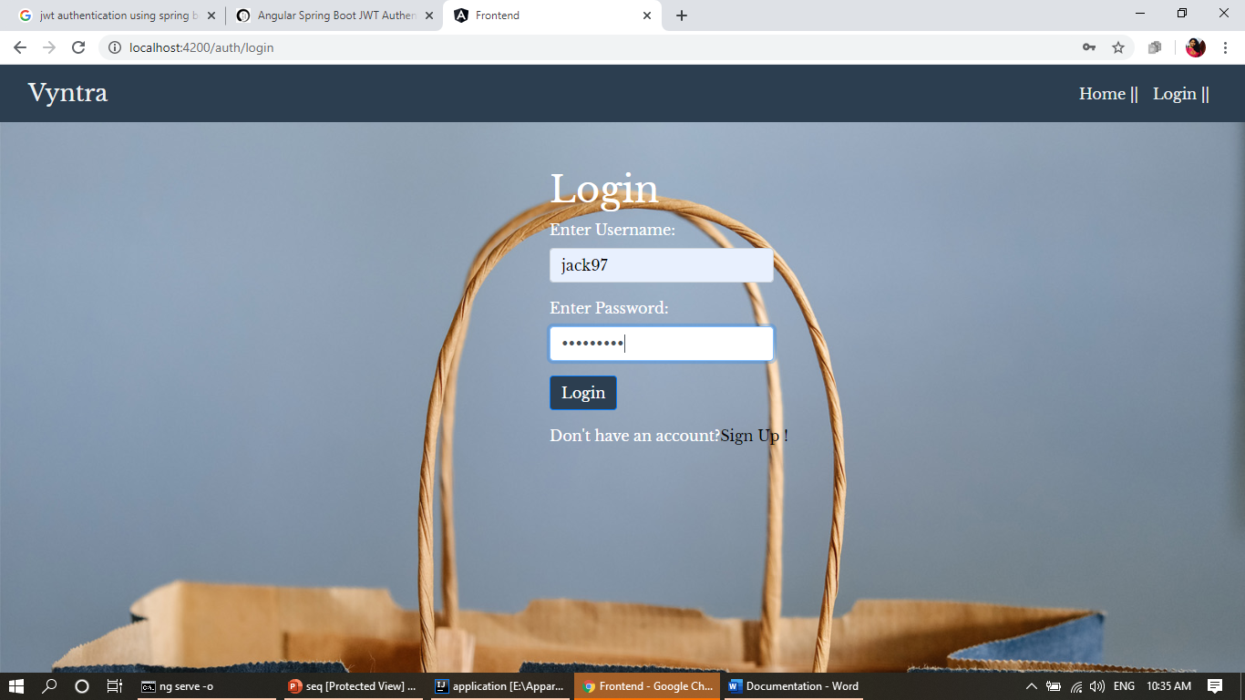

Image 2: Login Page

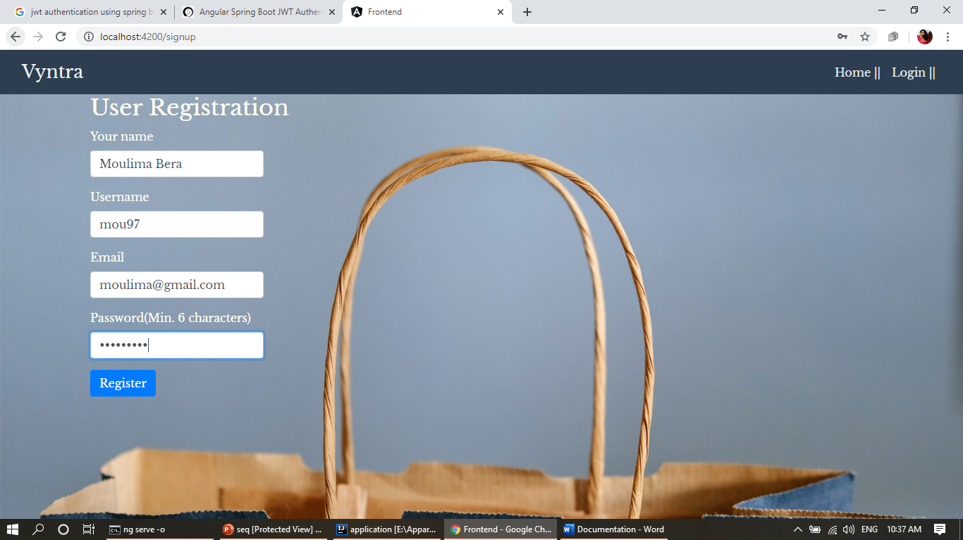

Image 3: User Registration Page

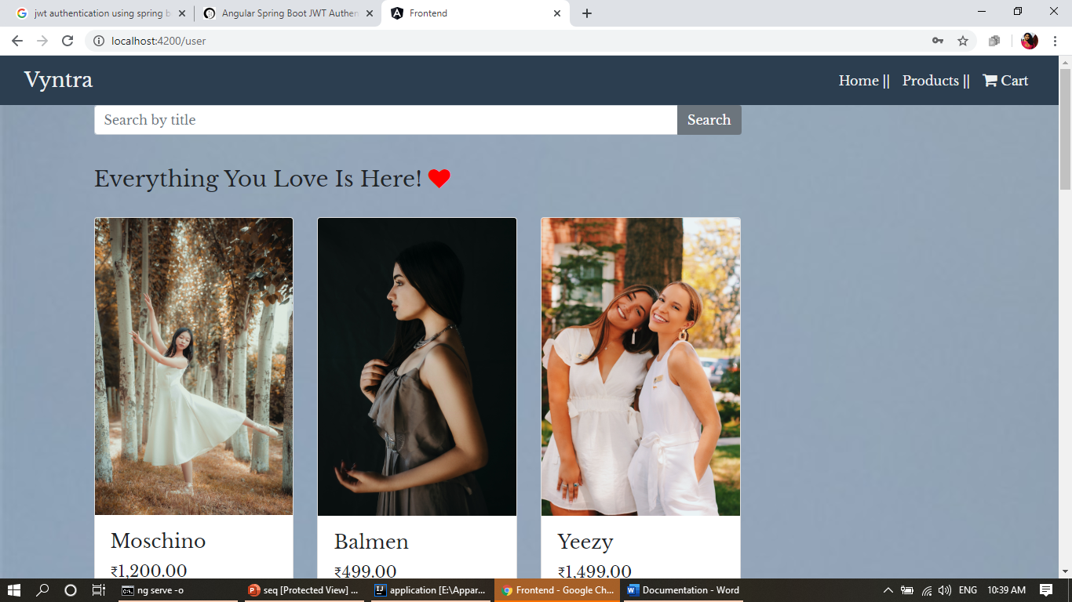

Image 4: Products Page for user

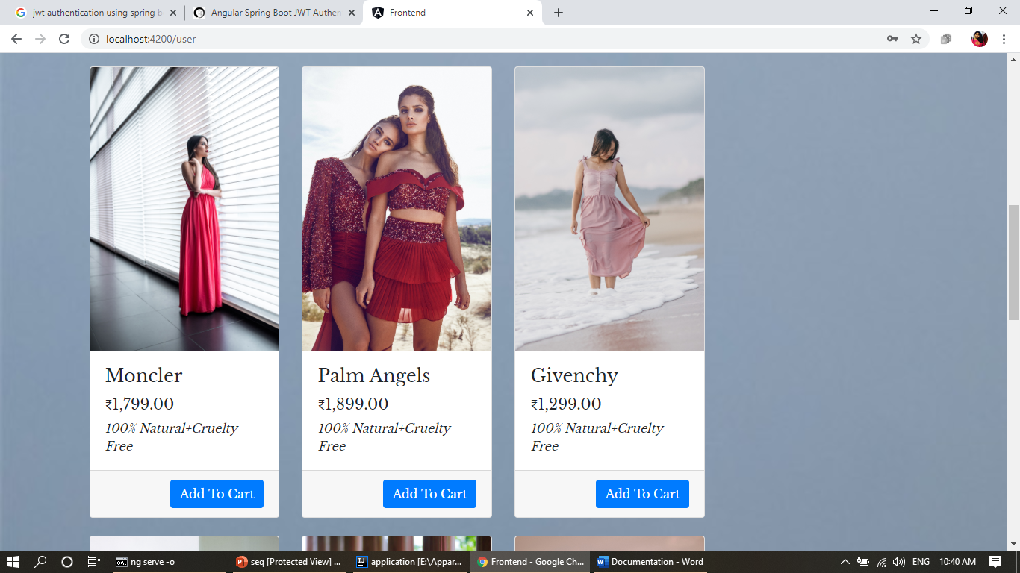

Image 5: Product Page view for user

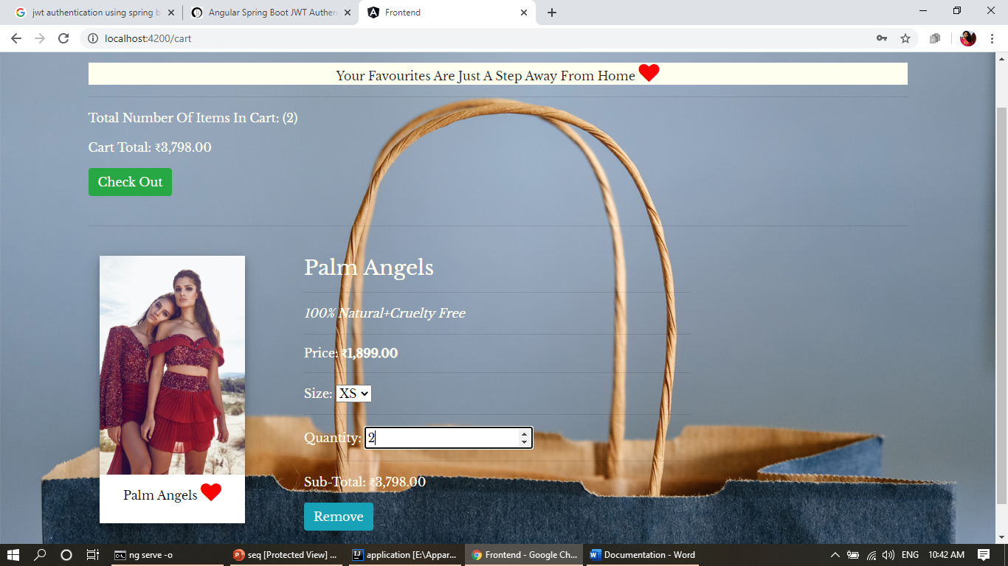

Image 6: Cart Page

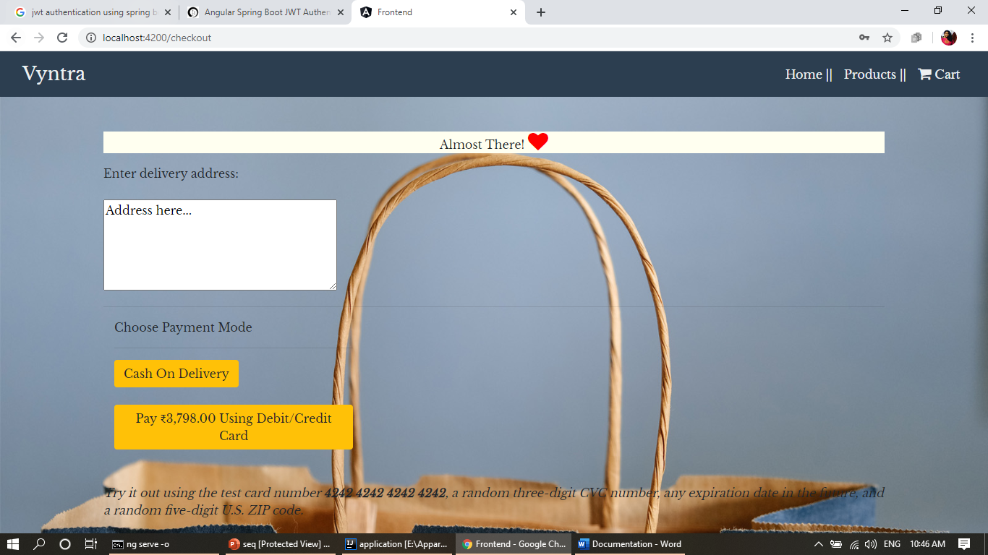

Image 7: Check Out Page

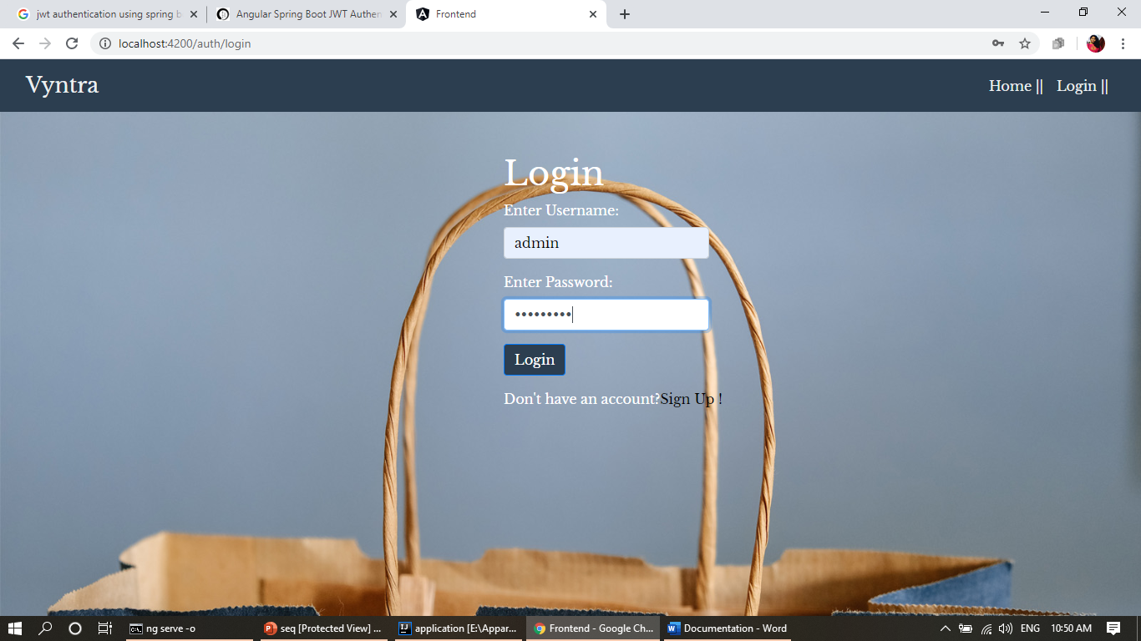

Image 8: Admin login

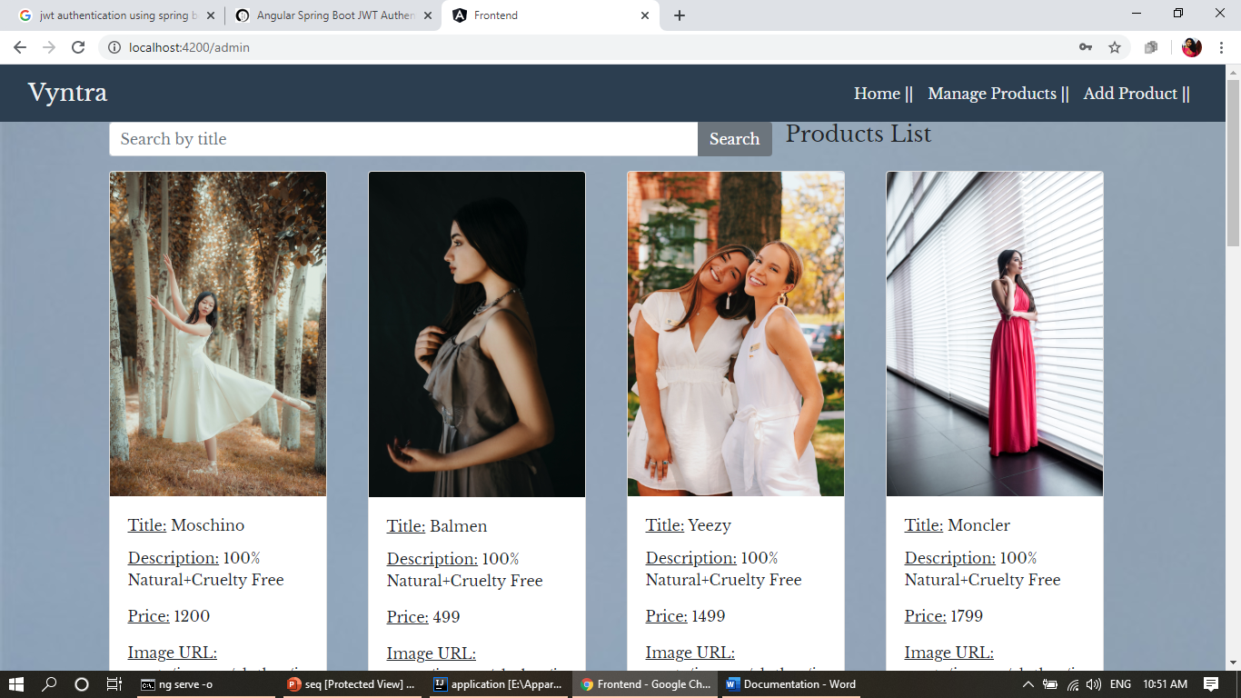

Image 9: Admin Manage Product Page

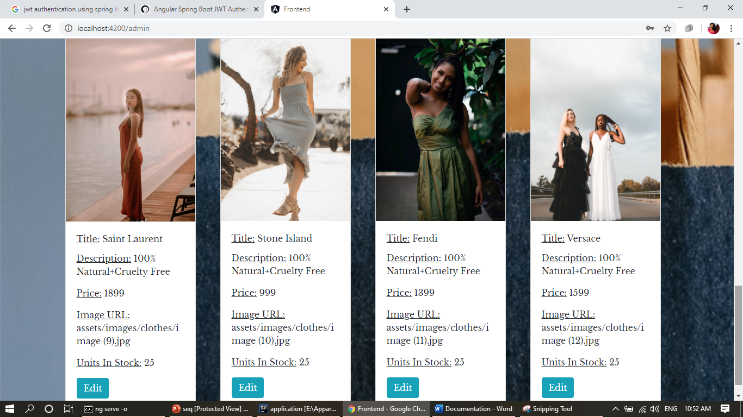

Image 10: Admin Manage Product Page

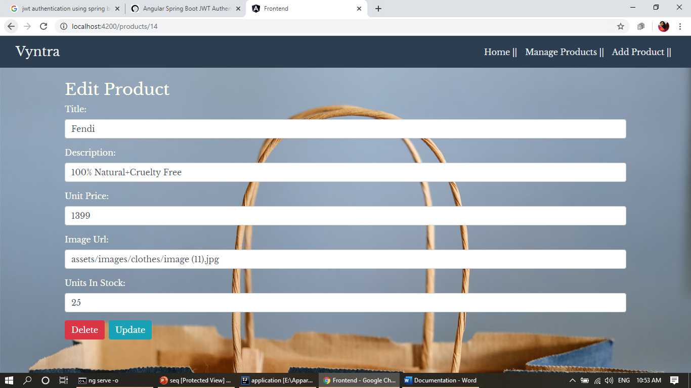

Image 11: Edit Existing Product In Database

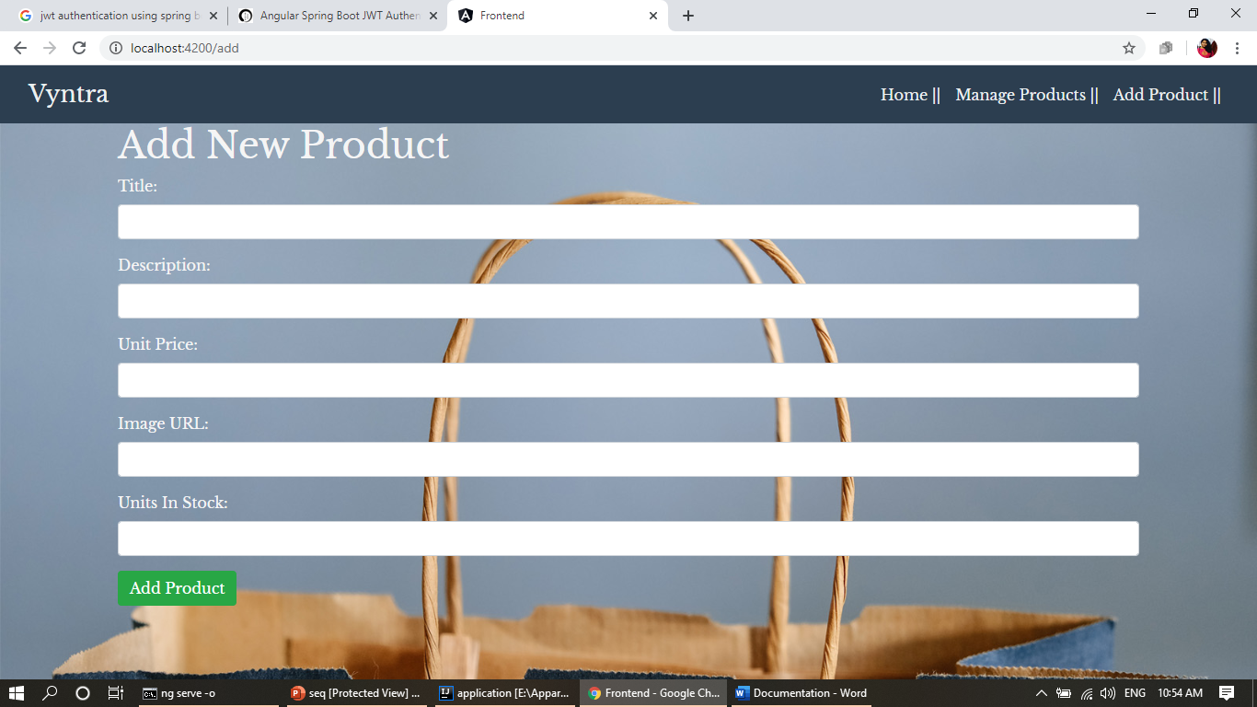

Image 12: Add a new product to database